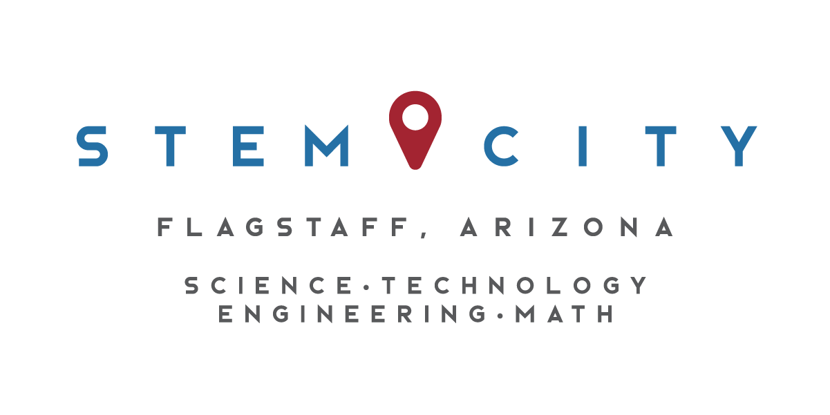

STEM City Executive Summary

January – December 2016

Business-School Connections
Over 100 Connections were made during the 2016 calendar year. These Connections included over 60 businesses, government agencies or organizations. Many of the Connections are sustained partners we have cultivated for the past four years. However, new partners are added each year. 114 classes or clubs were impacted, reaching almost 3,000 students.

These connections include long-term class mentorships, one-period or one-day class programming, or STEM club activities and fieldtrips. The primary business–engagement model is the Scientists in the Classroom program developed by Jillian Worssam, an 8th grade science teacher at Sinagua Middle School (SMS). STEM City also connects the Killip STEM Academy with STEM professionals, as well as any other educator or school that requests assistance in finding STEM professionals for their classes or clubs.

NAU- School Connections
STEM City had three NAU School of Earth Sciences and Environmental Sustainability undergraduate students complete internships in the fall of 2016. Two of them assisted with the Future City program at SMS, and one assisted with alternative energy lessons, also at SMS. Many NAU students and professors are engaged in long-term partnerships with teachers, including the Center for Ecosystem Science and Society that partners with a teacher at SMS. A Global Engineering Outreach group completed a three-year project at Killip Elementary School, successfully working with students to design and build a roof water collection system. Many NAU affiliated personnel assist with the FIRST Robotics tournaments in Flagstaff. NAU graduate students, alumni, and professors have assisted in guiding local field trips and leading investigations with students in classes.

Present Grants
BioSEEK
Initial funding from APS and the Flagstaff Community Foundation has been bolstered by present funding from the Arizona Community Foundation of Flagstaff to maintain our bioscience outreach program. STEM City provides six unique BioScience Education Enhancement Kits (BioSEEK) to local educators. Descriptions are under the Resources tab on the STEM City website.

Engineering is Elementary Out-of-School Time Program
Funding from the Arizona Community Foundation provided personnel time and materials to build two EiE kits for 3rd – 5th graders, and two for 6th – 8th graders. These are available for loan through STEM City. Descriptions are under the Resources tab on the STEM City website.

SFAz + 8 Grant with Coconino Community College
SFAz received an NSF grant to fund Engineering Pathways through eight rural community colleges in Arizona. STEM City coordinator Mindy Bell assists in providing engineering materials (including two additional EiE kits at each school) and field trip funds to FUSD Middle School STEM teachers.

iCREATE Grant with NAU’s Center for Science Teaching and Learning
STEM City is a partner on the iCREATE (Innovative Collaborative Research Experience and Technical Education) NSF grant with the Center for Science Teaching and Learning (CSTL) at NAU, the Coconino Association for Vocations, Industry, and Technology, TGen North, Coconino County Health Department, and North Country HealthCare among others. This program adds a community engagement and a problem-based curriculum with a technology component to the regular CTE Bioscience course in Arizona. High school students receive 6 dual-enrollment credits from Coconino Community College for this challenging, accredited course.

PLANETS Grant with NAU’s Center for Science Teaching and Learning
STEM City is a partner on the PLANETS (Planetary Learning at the Nexus of Engineering, Technology, and Science) grant with the CSTL, USGS Astrogeology Center, the Engineering is Elementary (EiE) team at the Museum of Science Boston, and others, to create, test, refine and disseminate EiE kits with science-rich content in Flagstaff and beyond.

STEM VISTA Grant with NAU’s Civic Service Institute
STEM City, in collaboration with the Civic Service Institute at NAU hosts an AmeriCorps VISTA (Volunteers in Service to America) Leader at STEM City Center and collaborates on fulfilling the goals of the 14 other VISTA members placed in schools and non-profits to increase STEM capacity through the Flagstaff STEM Education Project.

Community Engagement and Collaborations
STEM City Center met and collaborated with many people and organizations involved in STEM-related programming.

- Collaborated with Karin Eberhard and Jillian Worssam on delivering the 3rd Annual and then planning the 4th Annual Flagstaff Community STEM Celebration at the NAU Skydome
- Collaborated with NALA on soliciting nominees, judging nominations, and then putting on the 4th Annual STEM Awards
- Worked with the Northern Arizona Chess Association to have an All Girls Chess Tournament at Lowell Observatory
- Served on the Viola Excellence in Science Education Awards Panel
- Helped recruit volunteers for the Arizona Project WET 4th grade Water Festival
- Assisted USGS in distributing topographic maps, posters, and Earth Science week packages to Flagstaff educators.
- Recruited STEM professionals for the Flagstaff Festival of Science Speakers Series
- Recruited one-on-one STEM Mentors for 7th and 8th grade Honors Science students at Sinagua Middle School
- Recruited women STEM professionals for the Girls on the Run Hall of Heroes
- Recruited judges for four school science fairs
- Recruited volunteers for local robotics tournaments
- Met with the City of Flagstaff Convention and Visitors Bureau on how STEM City could potentially be better marketed
- Represented STEM City at the Friends of the Rio de Flag meeting at Coyote Springs
- Maintained eight Engineering Kits for outreach activities using EiE.org curriculum
- Presented at Girl Scout leaders meeting on STEM City services and kits
- Held second Code.org professional development with Janice Mak at NACET Accelerator for local educators
- Worked with Christian Marcum, an NAU graduate, on marketing materials
- Served on the Science education panel for the 2016 Viola Awards
- Recruited volunteers for three school science fairs (Marshall Elementary, Flagstaff Junior Academy, and Flagstaff Community Christian School)
- Recruited volunteers for STEM events (robotics tournaments, etc.)
- Edited grant proposals and wrote Letters of Support for four educators applying for STEM grants
- Worked on the Articles of Incorporation and Bylaws for STEM City
- Led a Swedish Exchange STEM Educator to STEM sites in Flagstaff
- Presented to the American Society of Civil Engineers on STEM City
- Collaborated with Martha Ostheimer and Julia Olsen to expand Teachers in Industry program to Northern Arizona
- Helped African Sisters in STEM get free STEM resources for their STEM programming

Grant Support/Funding
- Collaborated with the STEM City Board of Directors on a funded proposal for $25,000 from the City of Flagstaff via the Flagstaff Arts Council to fund STEM City programs
- Collaborated with the STEM City Board of Directors on a funded proposal from the NARBHA Institute to fund STEM City facilities
- Collaborated on a proposal with NACET and the Wonder Factory on an unfunded summer STEM Camp
- Assisted several educators in successful grant and award proposals
- Assisted with the educational portion of the unfunded Merriam-Powell Center for Environmental Research proposal for a Flagstaff-based Long-term Ecological Research site

Represented STEM City at:
- Science in the Park with the Flagstaff Festival of Science
- Flagstaff Star Party
- Science of Sound event at Flagstaff Family Food Center
- National STEM Conference in Phoenix
- Two FIRST Robotics Tournaments in Flagstaff
- TeenWorks Program with Coconino County Career Center
- NACET Client Gatherings
- Flagstaff Leadership Program science education day

Social/Print Media
- Website – www.flagstaffstemcity.com - Maintain and update STEM Events calendar, refreshed content, wrote 51 blogs on STEM events in Flagstaff
- Wrote 26 newsletters to the STEM Community (440 members)
- Wrote 22 newsletters for Flagstaff teachers (290 members)
- Facebook – www.facebook.com/flagstaffscienceconnection - highlights STEM events in Flagstaff; daily postings
- Twitter – www.twitter.com/flagstemcity - connect to Facebook feeds and initiated individual event feeds
- Arizona Daily Sun – helped develop and submitted STEM City page for annual Science and Research Special Edition
- Radio – interviewed on two local radio stations to promote Flagstaff Community STEM Celebration
- TV – interviewed by Andre Adauto at the STEM Celebration for Flag4TV
- Maintain file of STEM-related articles from the Arizona Daily Sun

STEM-related Committees/Groups
- LAUNCH Flagstaff (formerly the Flagstaff Commission on Excellence in Education)
- Chamber of Commerce Education and Workforce Development Committee
- Education Committee of the Northern Arizona Leadership Alliance

