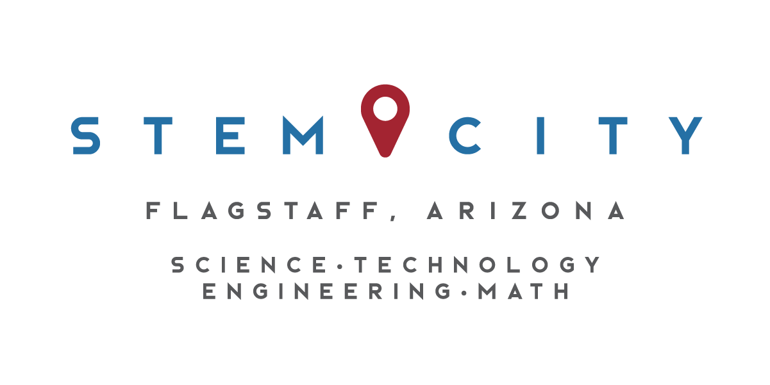

STEM City Executive Summary

January – December 2017

Business-School Connections
Over 100 STEM Connections were made during the 2017 calendar year. These Connections included over 60 businesses, government agencies or organizations. Many of the Connections are sustained partners we have cultivated for the past five years. However, new partners are added each year. 120 classes or clubs were impacted, reaching over 3,000 students.

These connections include long-term class mentorships, one-period or one-day class programming, or STEM club activities and fieldtrips. The primary business–engagement model is the Scientists in the Classroom program founded by Jillian Worssam, an award-winning science teacher at Sinagua Middle School (SMS). STEM City also connects the Killip STEM Academy with STEM professionals, as well as any other educator or school that requests assistance in finding STEM professionals for their classes, clubs, or science fair judging.

NAU- School Connections
Key NAU-School partnerships include the Center for Ecosystem Science and Society (ECOSS) partnering with a class at SMS for the second year, Bret Pasch mentoring an SMS class and presenting in several others, many graduate students and instructors presenting to the CAVIAT iCREATE bioscience class at NAU, two undergraduate students from NAU’s School of Earth Sciences and Environmental Sustainability completing internships with the Future City program at SMS. The new NAU Club Girls Teaching Girls had after school programming and tutoring in Killip Elementary, Kinsey Elementary, and with the Boys and Girls Club of Flagstaff. Five students in the social work department organized and ran a career day with primarily STEM careers at Kinlani Bordertown Dormitory. Many NAU affiliated personnel assist with the FIRST Robotics tournaments in Flagstaff. NAU graduate students, alumni, and professors assisted in guiding local field trips and leading investigations with students in classes. And NAU hosted the annual Flagstaff Community STEM Celebration in the NAU Skydome for the 4th consecutive year.
STEM Programming

STEM City maintains:
- Engineering kits for both in and out-of-school time use by request as available (http://www.flagstaffstemcity.com/engineering-is-elementary.html)
- Bioscience kits (http://www.flagstaffstemcity.com/bioseek---bioscience-kits.html)
- Environmental Science kits (http://www.flagstaffscies.org/)

STEM City assists with finding STEM professionals for several programs:
- STEM Connects - for all teachers that request assistance
- Scientists in the Classroom – Monthly Classroom Mentor Model
- Scientists in the Classroom – One-on-one Student Mentor Model

STEM City collaborates on several annual events:
- Flagstaff Community STEM Celebration in the NAU Skydome each spring
- STEM Awards Night (aka “the STEMmies”)
- All Girls Chess Tournament in January
- Support for Flagstaff Festival of Science

Present Grants/Support
- STEM Funders Network STEM Learning Ecosystems – funds travel and participation in professional development conferences for two years, and provides one year of technical assistance to grow Flagstaff’s STEM Learning Ecosystem. Note that Brigid, Mindy and Julie Pastrick all attended and presented at the national meeting in Kansas City where we gained invaluable insights into STEM efforts in other communities and potential for future funding from the STEM Funders Network
- Flagstaff Arts Council – 1.5 years of operational and programmatic support
- NARBHA – one year of operational support
- NALA – annual support for the STEM Awards Night
- NAU – one year (renewable?) for expanding the Scientists in the Classroom program
- iCREATE grant with NAU’s Center for Science Teaching and Learning – supports STEM Coordinator in connecting STEM professionals to the bioscience class
- PLANETS grant with NAU’s Center for Science Teaching and Learning – supports STEM Coordinator in recruiting pilot instructors and assisting with piloting program
- Flagstaff STEM Education Project with NAU’s Civic Service Institute - hosts an AmeriCorps VISTA (Volunteers in Service to America) Leader at STEM City Center and assists the 14 other VISTA members placed in schools and non-profits to increase STEM capacity, especially to underserved populations
- NOAA Planet Stewards Teacher Workshop – funded 10k to put on a regionally-focused workshop for K-12 educators on mitigating extreme weather challenges

Community Engagement and Collaborations
STEM City Center met and collaborated with many people and organizations involved in STEM-related programming.

- Collaborated with Karin Eberhard and Jillian Worssam on delivering the 4th Annual and planning the 5th Annual Flagstaff Community STEM Celebration at the NAU Skydome
- Collaborated with the Northern Arizona Leadership Alliance on soliciting nominees, judging nominations, and organizing the 5th Annual STEM Awards
- Worked with the Northern Arizona Chess Association and Lowell Observatory on the 2nd All Girls Chess Tournament at Lowell Observatory
- Served on the Viola Excellence in Science Education Awards Panel
- Helped recruit volunteers for the Arizona Project WET 4th grade Water Festival
- Recruited STEM professionals for the Flagstaff Festival of Science Speakers Series
- Recruited one-on-one STEM Mentors for 7th and 8th grade Honors Science students at Sinagua Middle School
- Recruited volunteers for local robotics tournaments
- Maintained eight Engineering Kits for outreach activities using EiE.org curriculum
- Recruited volunteer for the Ready Set Code Camp put on by Mark Cox with the Boys and Girls Club of Flagstaff and the Greater Flagstaff Chamber of Commerce
- Recruited volunteers for four school science fairs (Cromer Elementary, Marshall Elementary, Flagstaff Junior Academy, and Flagstaff Community Christian School)
- Edited grant proposals and wrote Letters of Support for four educators applying for STEM grants
- Collaborated with Martha Ostheimer and Julia Olsen to expand Teachers in Industry program to Northern Arizona
- Connected Ben Ruddell (School of Informatics, Computing and Cyber Security, NAU) and the Center for Science Teaching and Learning, to get a supplemental grant to recruit and train citizen scientists to pilot the Flagstaff portion of the FEWS project.
- Recruited teachers and students for the Student Climate Action Challenge with the City Sustainability section

Social/Print Media
- Website – www.flagstaffstemcity.com - Maintain and update STEM Events calendar, refreshed content, wrote or edited 42 blogs on STEM people and events in Flagstaff
- Wrote 21 newsletters to the STEM Community (440 members)
- Wrote 19 newsletters for Flagstaff teachers (303 members)
- Wrote 3 newsletters for Flagstaff Principals and Heads of Schools (28 members)
- Facebook – www.facebook.com/flagstaffscienceconnection - highlights STEM events in Flagstaff; daily postings
- Twitter – www.twitter.com/flagstemcity - connect to Facebook feeds and initiated individual event feeds
- Arizona Daily Sun – helped develop and submitted STEM City page for annual Science and Research Special Edition
- Maintain file of STEM-related articles from the Arizona Daily Sun

STEM-related Committees/Groups
- LAUNCH Flagstaff (formerly the Flagstaff Commission on Excellence in Education)
- Chamber of Commerce Education and Workforce Development Committee
- Education Committee of the Northern Arizona Leadership Alliance
- LAUNCH Flagstaff including Postsecondary Education Community Action Network
- Chamber of Commerce Education and Workforce Development Committee
- Northern Arizona Leadership Alliance Education Taskforce
- STEM VISTA Advisory Council
- STEM City Education Committee
- Flagstaff Ecology Education Team
- Northern Arizona Association of Women in STEM

